Task 1:
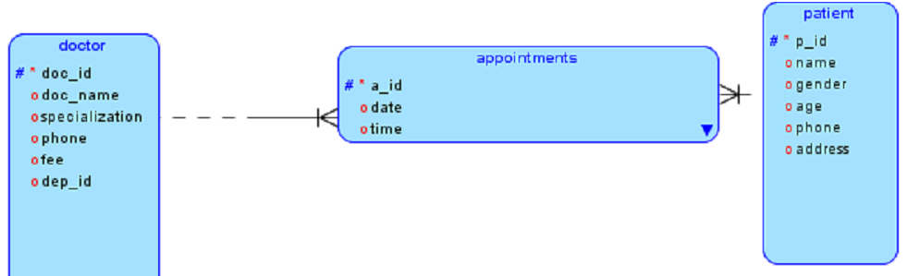
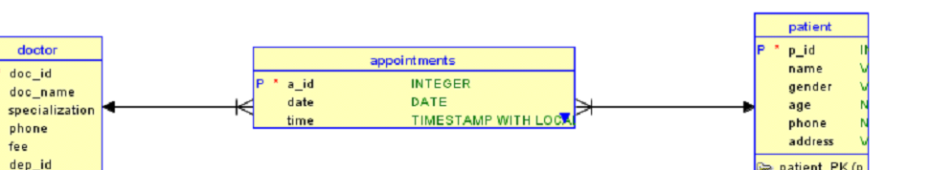

SELECT
Pat.name,
Doc.doc_name,
Dept.dep_name,
Appt.date
FROM
appointments Appt,
patient Pat,
doctor Doc,
departments Dept
WHERE
Appt.patient_p_id = Pat.p_id
AND Appt.doctor_doc_id = Doc.doc_id
AND Doc.dep_id = Dept.dep_id;

SELECT
patient.name,
doctor.doc_name,
departments.dep_name,
appointments.date
FROM appointments
NATURAL JOIN patient
NATURAL JOIN doctor
NATURAL JOIN departments;

SELECT
doc_name,
fee
FROM doctor d
WHERE EXISTS (
SELECT 1
FROM departments dep
WHERE d.dep_id = dep.dep_id
AND dep.dep_name = 'Cardiology'
);

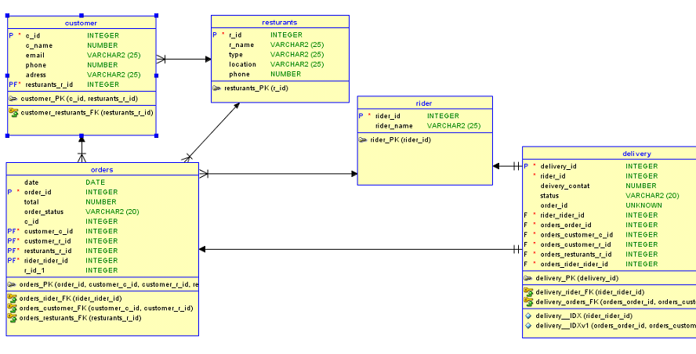

Task 2;

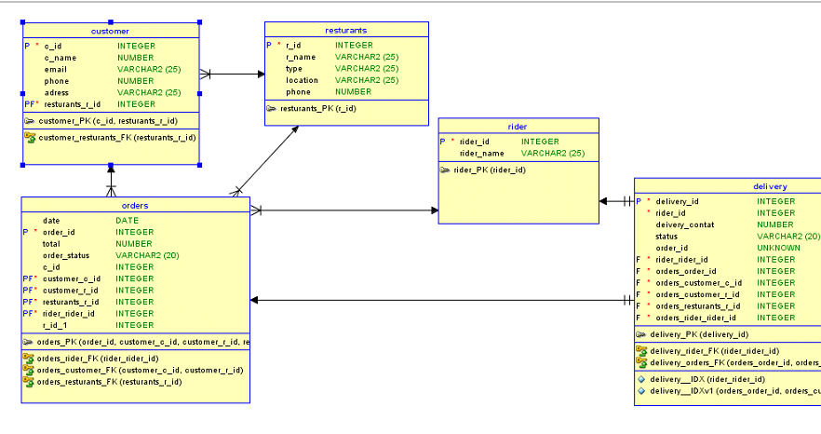
SELECT
CUSTOMERS.c_name,
RESTAURANTS.r_name,
ORDERS.total,
ORDERS.status
FROM
ORDERS
INNER JOIN
CUSTOMERS ON ORDERS.customer_id = CUSTOMERS.customer_id
INNER JOIN
RESTAURANTS ON ORDERS.restaurant_id = RESTAURANTS.restaurant_id;

TASK 03;

SELECT
STUDENTS.first_name,
STUDENTS.last_name,
COURSES.c_title,
INSTRUCTORS.first_name AS instructor_first_name,
INSTRUCTORS.last_name AS instructor_last_name
FROM
ENROLLEMENTS
JOIN
STUDENTS ON ENROLLEMENTS.students_s_id = STUDENTS.s_id
JOIN
COURSES ON ENROLLEMENTS.courses_c_id = COURSES.c_id
JOIN
INSTRUCTORS ON COURSES.instructors_i_id = INSTRUCTORS.i_id;

SELECT
COURSES.c_title,
COURSES.credit_hour,
INSTRUCTORS.first_name AS instructor_first_name,
INSTRUCTORS.last_name AS instructor_last_name
FROM
COURSES
JOIN
INSTRUCTORS ON COURSES.instructors_i_id = INSTRUCTORS.i_id
WHERE
COURSES.semester = 'Fall 2025';

